UI/UX DESIGN ANALYSIS REPORT
Google Maps Mobile Application
Submitted By:
Name: Jeba Malai Suja.A
Register Number: 2617029
Department: BCA(I year)
College Name: Kamaraj College
TABLE OF CONTENT

1.Introduction
2. About Google Maps
3. Objectives
4. Features
5. UI Analysis
6. UX Analysis
7. Screenshots
8. Advantages
9. Disadvantages
10. Suggestions
11. Conclusion
12. References
INTRODUCTION
Google Maps is one of the most popular navigation and mapping applications developed by Google. It helps users find locations, explore places, get accurate directions, and view real-time traffic updates. The application provides various features such as route planning, satellite view, street view, nearby place search, and location sharing. Its simple interface and user-friendly design make it easy for people to travel, discover new places, and reach their destinations safely and efficiently. This report analyzes the User Interface (UI) and User Experience (UX) of the Google Maps mobile application by examining its design, usability, features, strengths, and areas for improvement.
ABOUT GOOGLE MAPS

Google Maps is a web-based mapping and navigation service developed by Google. It was launched in 2005 and is available on Android, iOS, and web platforms. The application helps users search for locations, find the best routes, and navigate using real-time GPS. It also provides live traffic updates, estimated travel time, public transport information, satellite imagery, street view, and nearby places such as restaurants, hospitals, petrol stations, hotels, and ATMs.
Google Maps is widely used for personal travel, business purposes, and location-based services. Its simple design, accurate navigation, and real-time information make it one of the most trusted mapping application

OBJECTIVES
The main objectives of this UI/UX Design Analysis Report are:
To study the user interface (UI) of the Google Maps mobile application.
To analyze the user experience (UX) provided by the application.
To understand the design elements such as layout, colors, icons, and navigation.
To identify the key features and functionalities of Google Maps.
To evaluate the strengths and weaknesses of the application.
To provide suggestions for improving the overall user experience.
Features
Features of Google Maps

- Google Maps provides many useful features that help users travel and explore places easily. Some of the main features are:
- Search Places – Search for locations, businesses, schools, hospitals, restaurants, and more.
- Navigation – Provides turn-by-turn directions for driving, walking, cycling, and public transport.
- Real-Time Traffic – Shows live traffic conditions and suggests faster routes.
- Satellite View – Displays satellite images of roads, buildings, and landscapes.
- Street View – Allows users to view places in 360-degree panoramic images.
- Nearby Places – Finds nearby restaurants, ATMs, petrol stations, hotels, and other services.
- Live Location Sharing – Users can share their real-time location with friends and family.
- Offline Maps – Users can download maps and use them without an internet connection.
- Saved Places – Save favorite locations for quick access later.
Voice Navigation – Provides voice guidance for safe and convenient navigation.

UI DESIGN ANALYSIS
The User Interface (UI) of Google Maps is clean, simple, and visually attractive. The home screen provides a search bar at the top, making it easy for users to search for any location. The map occupies most of the screen, giving users a clear view of roads, landmarks, and nearby places.
The application uses easy-to-understand icons, readable text, and well-organized menus. Different colors are used to represent roads, traffic conditions, water bodies, and landmarks, making the map easy to understand. Buttons such as Directions, Start, Saved, Contribute, and Updates are placed in convenient locations for quick access.
Overall, the interface is user-friendly, responsive, and suitable for both new and experienced users.

UI DESIGN ANALYSIS

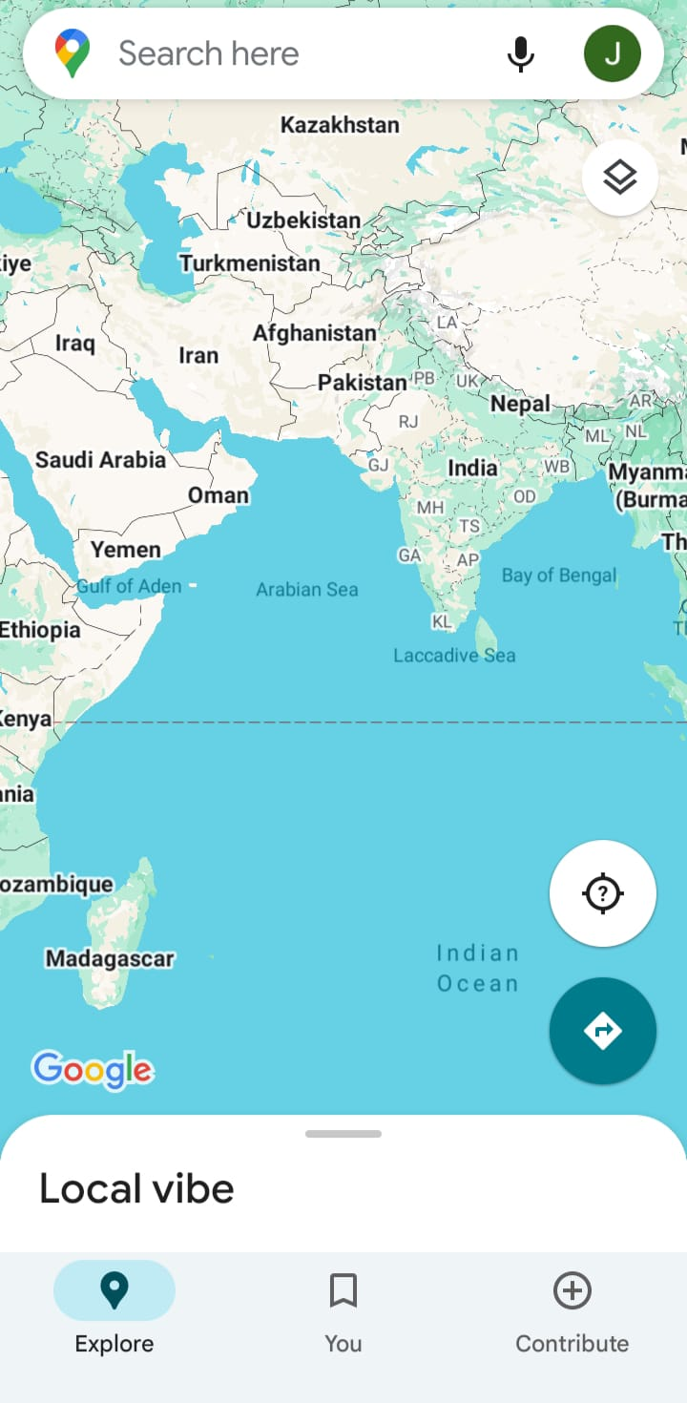

Figure 1:Google Maps Home Screen
UX DESIGN ANALYSIS
The User Experience (UX) of Google Maps is designed to provide a smooth, fast, and user-friendly navigation experience. Users can easily search for locations, get accurate directions, and explore nearby places with just a few taps. The application offers real-time traffic updates, estimated travel time, and multiple route options, making travel more convenient. The interface responds quickly, and important features are easy to access. Overall, Google Maps provides an efficient, reliable, and satisfying experience for users of all ages.

UX DESIGN ALAYSIS

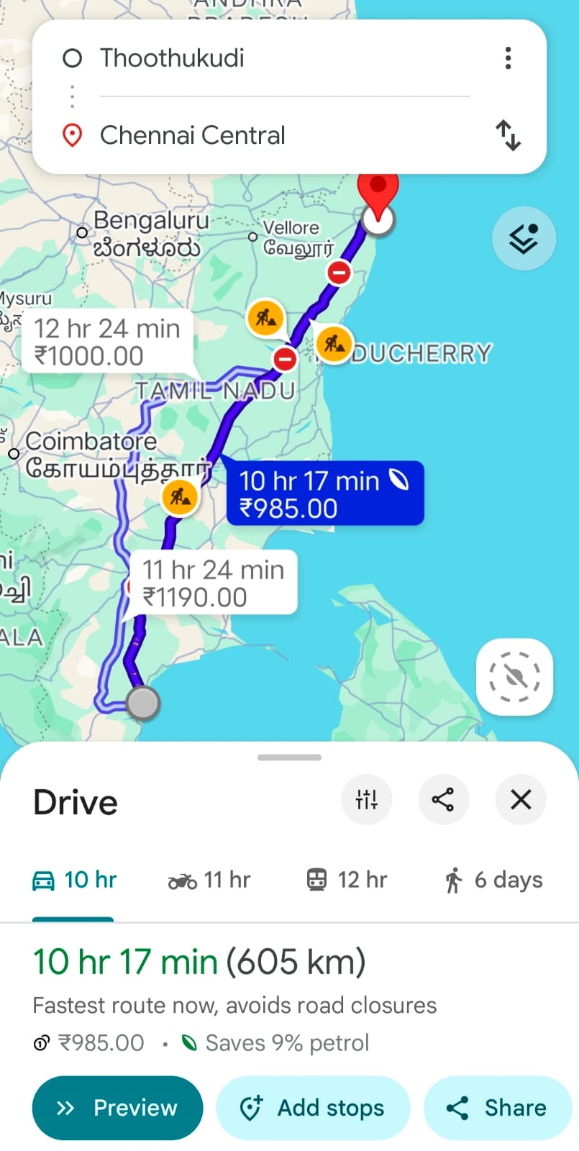

Figure2:Google Maps Route and Navigation Screen
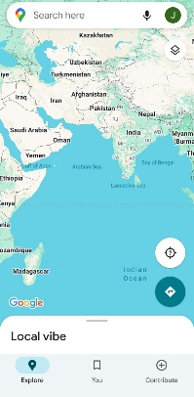
SCREENSHOT


Figure 1:Google Maps Home Screen Figure2:Google Maps Route
And navigations

ADVANTAGES

Google Maps provides many useful benefits to its users. Some of the major advantages are:
- Provides accurate and real-time navigation.
- Shows live traffic updates and estimated travel time.
- Helps users find nearby places such as restaurants, hospitals, hotels, and petrol stations.
- Supports multiple modes of transport, including car, bike, walking, and public transport.
- Easy to use with a simple and user-friendly interface.
- Allows users to share their live location with others.
- Available free of cost on Android, iOS, and web platforms.

SUGGESTIONS

Some suggestions to improve the Google Maps application are:
- Improve navigation accuracy in remote and rural areas.
- Reduce battery consumption while using GPS.
- Provide better offline map features for users without internet access.
- Improve the accuracy of real-time traffic updates.
- Add more local language support for easier navigation.
- Update map information more frequently to avoid outdated routes.
- Enhance voice navigation with clearer instructions.

CONCLUSION
Google Maps is one of the most useful and reliable navigation applications available today. It provides accurate directions, real-time traffic updates, and many helpful features that make travelling easier and more convenient. The application has a simple and user-friendly interface, which offers a smooth user experience. Although it has a few limitations, its advantages greatly outweigh its disadvantages. Overall, Google Maps is an excellent mobile application for navigation and location-based services.
REFERENCE

- Google Maps Mobile Application.
- https://maps.google.com⁠�
- https://play.google.com/store/apps/details?id=com.google.android.apps.maps⁠�
- UI/UX Design Course Materials.

